Solved past paper of basic medical science(First aid and public health ) ii (PMF)

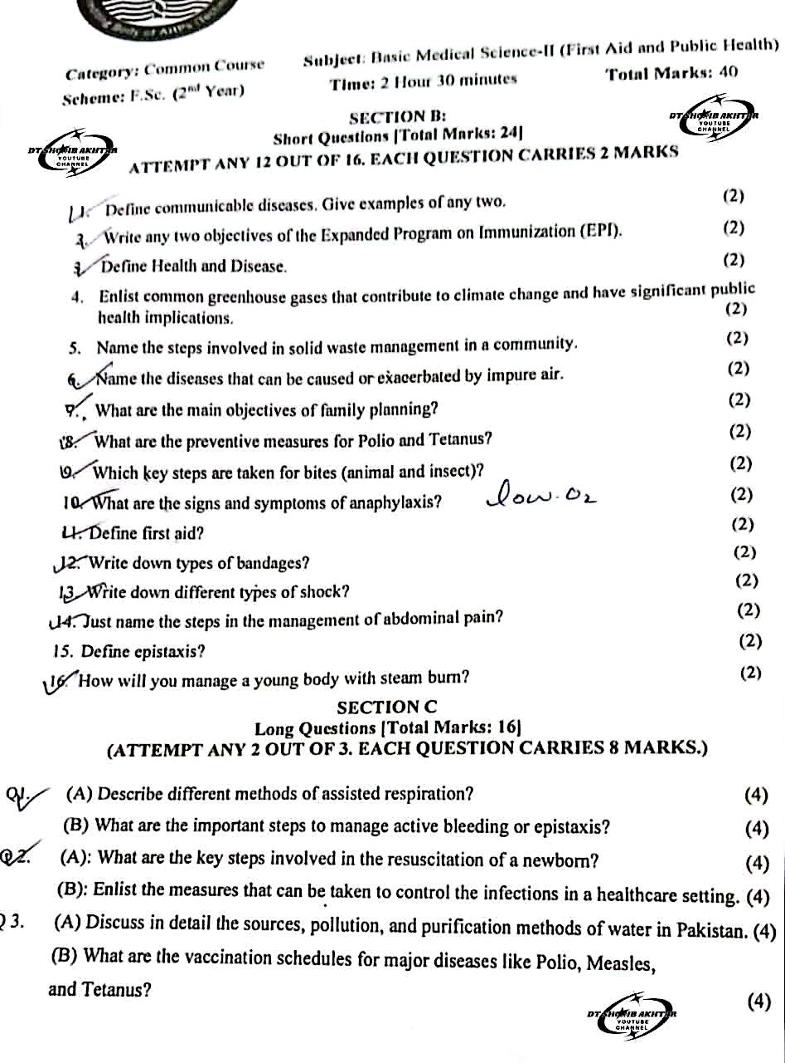

SECTION B – Short Questions
(Attempt any 12 – Each = 2 marks)
👉 I’m solving ALL 16 for your practice.

1. Define communicable diseases. Give two examples.
Communicable diseases are diseases that spread from one person to another directly or indirectly through air, water, food, contact, or vectors.
Examples: Tuberculosis, Measles.

2. Write any two objectives of the Expanded Program on Immunization (EPI).
- To prevent childhood diseases by vaccination.
- To reduce infant and child mortality rate.

3. Define Health and Disease.
- Health: A state of complete physical, mental, and social well-being, not merely absence of disease.
- Disease: A condition in which normal body functions are disturbed.

4. Enlist common greenhouse gases causing climate change with public health effects.
- Carbon dioxide (CO₂)
- Methane (CH₄)
- Nitrous oxide (N₂O)

5. Steps involved in solid waste management in a community.
- Collection
- Segregation
- Transportation
- Disposal (recycling, landfill, incineration)

6. Name diseases caused or aggravated by impure air.
- Asthma
- Bronchitis
- Lung cancer
- Chronic obstructive pulmonary disease (COPD)

7. Main objectives of family planning.
- To control population growth
- To space births
- To improve maternal and child health

8. Preventive measures for Polio and Tetanus.
- Polio: OPV/IPV vaccination, proper sanitation
- Tetanus: TT vaccination, clean wound care, sterile instruments

9. Key steps for animal and insect bites.
- Wash wound with soap and water
- Apply antiseptic
- Seek medical care / vaccination if needed

10. Signs and symptoms of anaphylaxis.
- Difficulty breathing
- Swelling of face or lips
- Low blood pressure
- Skin rash and itching

11. Define First Aid.
First aid is the immediate and temporary care given to an injured or ill person until medical help arrives.

12. Types of bandages.
- Roller bandage
- Triangular bandage
- Adhesive bandage

13. Different types of shock.
- Hypovolemic shock
- Cardiogenic shock
- Septic shock
- Anaphylactic shock

14. Steps in management of abdominal pain (name only).
- Keep patient at rest
- Do not give food
- Observe symptoms
- Refer to hospital

15. Define Epistaxis.
Epistaxis means bleeding from the nose.

16. Management of a young body with steam burn.
- Cool area with running water
- Do not burst blisters
- Cover with clean cloth
- Seek medical help

SECTION C – Long Questions
(Attempt any 2 – Each = 8 marks)
👉 I am solving ALL questions.

Q1 (A): Describe different methods of assisted respiration.

Q1 (A): Describe different methods of assisted respiration.
(4–8 marks answer – suitable for PMF)

Introduction
Assisted respiration refers to artificial methods used to support or maintain breathing in a person who is unable to breathe adequately on their own due to illness, injury, or unconsciousness. It is an important life-saving measure in first aid and emergency care.

Methods of Assisted Respiration

1. Mouth-to-Mouth Respiration
This is the simplest and most commonly used method of assisted breathing in emergencies.
Procedure:
- Place the patient on a flat surface
- Open the airway by head-tilt and chin-lift
- Pinch the nose closed
- Seal your mouth over the patient’s mouth
- Blow air until the chest rises
Uses:
- Drowning
- Cardiac arrest
- Unconscious patients

2. Mouth-to-Nose Respiration
This method is used when mouth-to-mouth is not possible.
Procedure:
- Close the patient’s mouth
- Blow air through the nose
- Watch chest rise
Uses:
- Mouth injuries
- Jaw fractures
- Infants

3. Bag and Mask Ventilation (Ambu Bag)
A self-inflating bag attached to a mask is used to deliver air or oxygen to the patient.
Features:
- Provides controlled ventilation
- Can deliver high-concentration oxygen
- Used by trained healthcare workers
Uses:
- Emergency rooms
- Ambulances
- Operation theaters

4. Oxygen Therapy
Oxygen is given to patients who can breathe but have low oxygen levels.
Methods:
- Nasal cannula
- Face mask
Uses:
- Respiratory diseases
- Trauma
- Shock and cardiac conditions

5. Mechanical Ventilation
A ventilator machine is used when the patient cannot breathe independently.
Features:
- Controls breathing rate and volume
- Used in ICUs
- Requires intubation
Uses:
- Severe respiratory failure
- Coma
- During major surgeries

Q1 (B): Important steps to manage active bleeding / epistaxis.

Q1 (B): Important steps to manage active bleeding / epistaxis

Introduction
Epistaxis refers to bleeding from the nose. It may occur due to trauma, hypertension, infection, dry air, nose picking, or bleeding disorders. Proper and timely management is important to prevent excessive blood loss and complications.

Steps for Management of Active Bleeding / Epistaxis

1. Position the Patient Properly
- Keep the patient sitting upright
- Lean the head slightly forward, not backward
- This prevents blood from flowing into the throat and airways

2. Apply Direct Pressure
- Pinch the soft part of the nose just below the nasal bone
- Maintain firm pressure for 10–15 minutes
- Ask the patient to breathe through the mouth

3. Apply Cold Compress
- Apply an ice pack or cold cloth over the nose and forehead
- Cold causes vasoconstriction, which helps stop bleeding

4. Calm and Reassure the Patient
- Anxiety increases blood pressure and bleeding
- Reassure the patient and keep them relaxed

5. Avoid Nose Blowing or Sneezing
- Advise the patient not to blow or pick the nose
- This can dislodge clots and restart bleeding

6. Check for Foreign Body or Injury
- Examine gently for trauma or foreign objects
- Do not insert instruments unless trained

7. Seek Medical Help
- If bleeding continues beyond 20 minutes
- If bleeding is severe or recurrent
- In cases of head injury or known bleeding disorders

Q2 (A): Key steps in resuscitation of a newborn.

Introduction
Newborn resuscitation is the immediate care given to a baby at birth who is not breathing or is breathing inadequately. The main objectives are to establish effective breathing, maintain circulation, and prevent hypothermia. Early and proper resuscitation can save the life of the newborn and prevent brain damage.

Key Steps in Newborn Resuscitation

1. Provide Warmth and Positioning
- Immediately dry the baby to prevent heat loss
- Remove wet towels and keep the baby warm
- Place the newborn on a flat, warm surface
- Position the head slightly extended to open the airway

2. Clear the Airway
- Clear secretions from mouth first, then nose using a suction bulb
- Avoid deep suction to prevent injury or bradycardia
- Ensure the airway is patent

3. Stimulate Breathing
- Gently rub the back or tap the soles of the feet
- This helps initiate spontaneous breathing
- Do not shake the baby

4. Assess Breathing and Heart Rate
- Check if the baby is breathing or crying
- Assess heart rate using stethoscope or umbilical pulse
- A heart rate above 100 beats per minute is normal

5. Provide Positive Pressure Ventilation (PPV)
- If the baby is not breathing or heart rate is below 100 bpm
- Use bag and mask ventilation
- Ensure proper mask seal and visible chest rise

6. Chest Compressions
- If heart rate remains below 60 bpm despite effective ventilation
- Start chest compressions
- Use a 3:1 ratio (3 compressions to 1 breath)

7. Administer Oxygen and Medications (if required)
- Give oxygen if cyanosis persists
- Medications may be given under medical supervision
- Establish intravenous or umbilical access if needed

8. Post-Resuscitation Care
- Keep the baby warm and monitor vital signs
- Observe breathing, color, and activity
- Transfer to neonatal intensive care if required

Q2 (B): Measures to control infections in healthcare settings.

Introduction
Infection control in healthcare settings refers to policies and practices used to prevent the spread of infections among patients, healthcare workers, and visitors. Proper infection control reduces hospital-acquired infections (HAIs) and improves patient safety.

Measures to Control Infections

1. Hand Hygiene
- Hand washing is the most effective method of preventing infection
- Wash hands with soap and water or use alcohol-based hand rub
- Perform hand hygiene before and after patient contact

2. Use of Personal Protective Equipment (PPE)
- Includes gloves, masks, gowns, and face shields
- Protects healthcare workers and patients from cross-infection
- PPE should be used according to the type of exposure

3. Sterilization and Disinfection
- Sterilization destroys all microorganisms including spores
- Disinfection reduces harmful microorganisms
- Proper sterilization of instruments prevents transmission of pathogens

4. Environmental Cleanliness
- Regular cleaning of floors, beds, equipment, and surfaces
- Use approved disinfectants
- Maintain proper ventilation and waste removal

5. Safe Disposal of Medical Waste
- Segregate waste using color-coded bins
- Sharp objects disposed in puncture-proof containers
- Prevents needle-stick injuries and spread of infections

6. Isolation of Infected Patients
- Patients with contagious diseases should be isolated
- Limits spread of infection to others
- Use barrier nursing when required

7. Vaccination of Healthcare Workers
- Staff should be vaccinated against hepatitis B, influenza, etc.
- Reduces risk of transmission within healthcare facilities

8. Training and Education
- Regular training on infection control practices
- Ensures adherence to standard precautions
- Promotes safe healthcare environment

Q3 (A): Sources, pollution, and purification of water in Pakistan.

Q3 (A): Sources, pollution, and purification of water in Pakistan

Introduction
Water is an essential requirement for life and public health. In Pakistan, safe drinking water is a major concern due to rapid population growth, industrialization, and poor sanitation. Understanding the sources of water, causes of pollution, and methods of purification is important for disease prevention and health promotion.

Sources of Water in Pakistan

1. Surface Water
Surface water is obtained from natural water bodies.
Examples:
- Rivers (Indus, Jhelum, Chenab)
- Lakes and reservoirs
- Canals and streams
Uses:
Drinking (after treatment), irrigation, and industrial purposes.

2. Groundwater
Groundwater is found beneath the earth’s surface.
Sources:
- Wells
- Tube wells
- Hand pumps
Importance:
Major source of drinking water in rural and urban areas.

3. Rainwater
Rainwater is a natural and relatively pure source of water.
Uses:
- Stored for domestic use
- Groundwater recharge

Water Pollution in Pakistan
Water pollution occurs when harmful substances contaminate water, making it unsafe for use.

Major Causes of Water Pollution
- Domestic Sewage
- Untreated human waste discharged into rivers and canals
- Causes water-borne diseases like cholera and typhoid
- Industrial Waste
- Chemicals, heavy metals, and toxic substances released by factories
- Highly dangerous to human health and aquatic life
- Agricultural Runoff
- Fertilizers and pesticides washed into water sources
- Causes chemical contamination
- Solid Waste Dumping
- Garbage and plastics thrown into water bodies

Purification of Water
Water purification removes physical, chemical, and biological impurities.

Methods of Water Purification

1. Boiling
- Kills bacteria, viruses, and parasites
- Simple and effective household method

2. Filtration
- Removes suspended particles
- Methods include sand filters and household filters

3. Chlorination
- Chlorine is added to kill microorganisms
- Common method used in public water supply

4. Sedimentation
- Heavy particles settle at the bottom
- Used before filtration in water treatment plants

5. Reverse Osmosis (RO)
- Removes dissolved salts and chemicals
- Common in urban areas

Q3 (B): Vaccination schedule for Polio, Measles, and Tetanus.

Introduction
Vaccination is one of the most effective preventive measures against infectious diseases. In Pakistan, vaccines are given under the Expanded Program on Immunization (EPI) to protect children and mothers from life-threatening diseases such as Polio, Measles, and Tetanus. A proper vaccination schedule helps in reducing morbidity and mortality.

1. Vaccination Schedule for Polio
Polio is a viral disease that can cause permanent paralysis, especially in children.

Polio Vaccines Used
- OPV (Oral Polio Vaccine)
- IPV (Inactivated Polio Vaccine)

Schedule
- At birth: OPV-0
- 6 weeks: OPV-1 + IPV
- 10 weeks: OPV-2
- 14 weeks: OPV-3
👉 Additional OPV doses are given during National Immunization Days (NIDs).

2. Vaccination Schedule for Measles
Measles is a highly contagious viral disease that can lead to pneumonia, diarrhea, blindness, and death.

Measles Vaccine
- Given as Measles-Rubella (MR) vaccine

Schedule
- 9 months: Measles (MR-1)
- 15 months: Measles (MR-2)

3. Vaccination Schedule for Tetanus
Tetanus is caused by Clostridium tetani and spreads through wounds and contaminated instruments. It is especially dangerous for newborns and pregnant women.

Tetanus Vaccine
- Tetanus Toxoid (TT) or Td

Schedule for Pregnant Women
- First pregnancy:
  - TT-1: As early as possible
  - TT-2: 4 weeks after TT-1
- Subsequent pregnancies:
  - One booster dose if previously vaccinated

Schedule for Children
- Given as part of DPT/Pentavalent vaccine at:
  - 6 weeks
  - 10 weeks
  - 14 weeks

